Generational change in MEYLE AG’s top management: Dr Karl J. Gaertner hands over the reins to Dirk Damaschke and Marc Siemssen

Hamburg, 7 September 2023 – After more than 28 years at the helm, majority shareholder Dr Karl J. Gaertner is stepping down from the MEYLE AG Executive Board. As of 1 September 2023, board members Dirk Damaschke and Marc Siemssen are now managing the spare parts manufacturer based in Hamburg together.

Dr Gaertner is therefore leaving operational management entirely in the experienced hands of his former board colleagues Dirk Damaschke and Marc Siemssen, who have been involved in company management and members of the Executive Board for several years now.

Dr Gaertner will remain Chairman of the Executive Board of the Wulf Gaertner Autoparts AG holding company, which is wholly owned by the family, and thus continue to support MEYLE with his expertise. This long-term transition is part of a generational change designed to prepare the company for the future. In addition, Dr Gaertner’s daughter Lisa Gaertner has joined the holding company’s Supervisory Board as a family representative.

‘For nearly three decades, I’ve had the opportunity to work with many dedicated colleagues and help transform MEYLE into an internationally successful company that is well known among our customers worldwide for its innovation and quality. And now the time has come for me to pass on the torch,’ says Dr Gaertner. ‘We, the owner family, plan to hand over MEYLE as a successful and internationally competitive company to the next generation. I’m delighted that Lisa Gaertner is assuming a new level of responsibility at the holding company and that we have found just the right team in Dirk Damaschke and Marc Siemssen to continue the brand’s success story.’

‘Dr Gaertner is a visionary entrepreneur who has transformed MEYLE into the innovative, global company and powerful brand that we are today,’ says Marc Siemssen, who is approaching his new responsibilities with gratitude and anticipation. ‘We’re assuming responsibility for the company in an exciting era of change that offers both challenges and opportunities for the entire automotive industry.’ ‘We’re starting from a strong position and have a wonderful team behind us,’ adds Dirk Damaschke. ‘We feel like we’re in the best position to advance key issues like electric mobility, sustainability and international growth with full force.’ Dirk Damaschke and Marc Siemssen are both delighted to continue working with Dr Gaertner in his new role.

Contact:
- MEYLE AG, Sarah Quinn, tel.: +49 (0)40 675 067 234, email: press@meyle.com

About the company
MEYLE AG is a company of Wulf Gaertner Autoparts AG.
MEYLE AG develops, produces and markets high-quality spare parts for passenger cars, vans and trucks for the independent aftermarket under the MEYLE brand. With its three product lines – MEYLE ORIGINAL, MEYLE PD and MEYLE HD – MEYLE offers precise solutions and parts for every situation and every driver, from competent workshop employee and ambitious rally driver to classic car enthusiast and every driver around the world who needs to be able to rely on their own car. MEYLE offers its customers over 24,000 reliable and durable spare parts manufactured in their own plants and at the facilities of select production partners. The MEYLE product portfolio is correspondingly sophisticated.
The Group has some 1,000 employees worldwide, including nearly 500 in Hamburg, at the logistics centre and the company headquarters. MEYLE works with partners, workshops and car mechanics in 120 countries worldwide to ensure that drivers can rely on MEYLE’s superior parts and solutions – that’s how MEYLE helps workshops to become the DRIVER’S BEST FRIEND.

MEYLE and sustainability
MEYLE’s headquarters are certified CO₂-neutral by the non-profit organisation Climate without Borders. To offset emissions, MEYLE has donated to a Gold Standard-certified climate protection project in Africa: Brunnen in Uganda (Wells in Uganda). A hydroelectric power plant in Turkey allows us to offset the unavoidable carbon emissions associated with the MEYLE HD suspension and steering product line. Plenty of helpful information is available on MEYLE’s website.
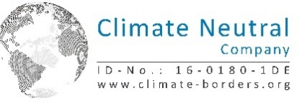

Follow us on our social media channels: Instagram, Facebook, LinkedIn and YouTube.

Pictures

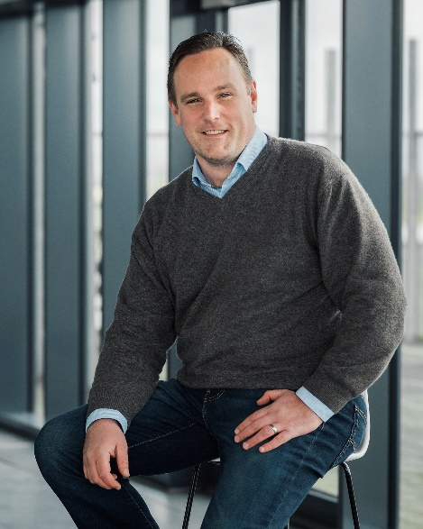

Caption: As of 1 September, Dirk Damaschke will lead the Hamburg-based spare parts manufacturer as part of the dual leadership. (Source: MEYLE AG)

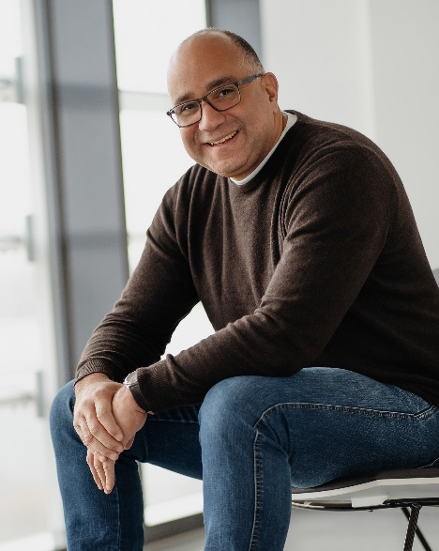

Caption: Marc Siemssen looks forward with gratitude and anticipation to the new task at Dirk Damaschke's side as the MEYLE AG's board member. (Source: MEYLE AG)

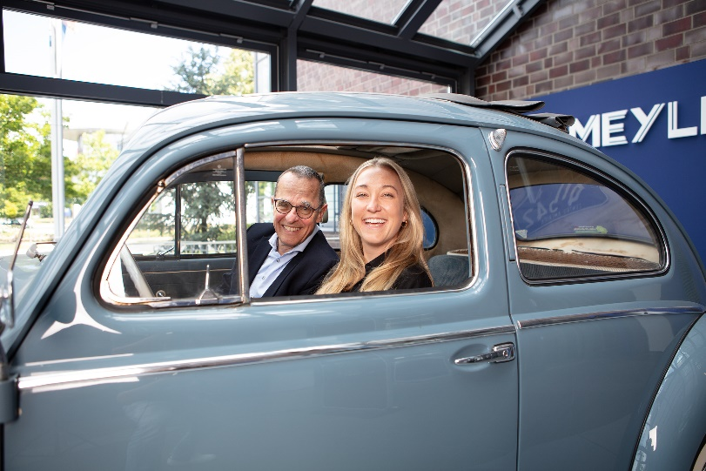

Caption: Dr. Karl J. Gaertner, Executive Chairman of the Board of the Holding Wulf Gaertner Autoparts AG, together with daughter Lisa Gaertner, who will in future sit on the Holding's Supervisory Board as the family's representative. (Source: MEYLE AG)

