MEYLE at the 2022 UN Climate Change Conference: focus on sustainability and conserving plastics
- MEYLE HD steering and suspension parts the first climate-neutral product line in the independent aftermarket
- MEYLE seeking to make its product range climate-neutral by 2030
- Eliminating protective caps conserves 15 tonnes of plastic a year
Hamburg, 09 November 2022. The UN Climate Change Conference is currently being held in Egypt and the Hamburg manufacturer MEYLE is there to input new ideas with its own sustainability endeavours. Climate change, the energy transition, the scarcity of resources, increased sustainability awareness and alternative drives – for manufacturers in the independent aftermarket too, the need to act has never been as great as it is today. MEYLE has now achieved an important milestone – the company is conserving 15 tonnes of plastic a year by eliminating plastic caps from MEYLE axial rods, control arms, ball joints and tie rods.
For some time now, MEYLE has been doing without the protective caps it previously used in the packaging for its axial rods. And now, control arms, ball joints and tie rods will likewise be delivered in optimised packaging that makes the plastic caps superfluous. MEYLE is additionally saving four tonnes of plastic a year by reducing its use of stretch wrap and thanks to its 2018/2019 transition to paper-based adhesive tape and shipping envelopes. MEYLE is therefore now saving around 19 tonnes of plastic a year.
MEYLE continuously works with its partners on increasing efficiency throughout the value chain and on doing business more sustainably. The Hamburg manufacturer has been working to improve its carbon footprint since 2018 and recently presented the first climate-neutral product line in the independent aftermarket – the carbon emissions of MEYLE HD steering and suspension parts are offset in cooperation with ClimatePartner.
On the occasion of the Climate Change Conference (COP27), member of the MEYLE AG Executive Board Marc Siemssen emphasises the following: ‘The impacts of climate change and the consequences of environmental destruction do not lie in the future. We must question our consumption and our conduct regarding resources today. MEYLE has therefore taken a close look at its use of plastics as one of many topics and we are consciously eliminating them from more and more parts. In addition, the concept behind MEYLE HD has been sustainable from the beginning – rather than buying a new part, which involves heavy resource usage, precedence is given to repairs performed using a spare part which is more durable than the original.’
MEYLE signed up to the UN Global Compact in 2021 to systematically accelerate and steadily expand its sustainability activities. Its current Report on Progress regarding human rights and the environment is available on the MEYLE CR website.
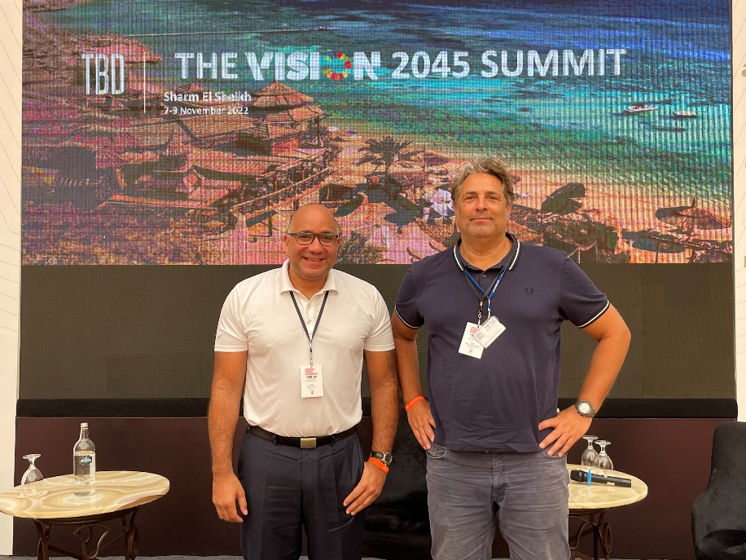
On site at the UN Climate Change Conference: Marc Siemssen, Member of the MEYLE AG Executive Board and Rainer Lange-Hitzbleck, Vice President Marketing & Communication (© MEYLE AG)
Contact:
- MEYLE AG, Sarah Quinn, Tel.: +49 40 67506 7234, email: press@meyle.com
- MEYLE AG, Benita Beissel, Tel.: +49 40 67506 7418, email: press@meyle.com

About the company
MEYLE AG is a company of Wulf Gaertner Autoparts AG.
MEYLE AG develops, produces and sells high-quality spare parts for passenger cars, vans and trucks for the independent aftermarket under the MEYLE brand. With its three product ranges – MEYLE ORIGINAL, MEYLE PD and MEYLE HD – MEYLE offers precise solutions and parts for every situation and every driver, from competent workshop employee and ambitious rally driver to classic car enthusiast and every driver around the world who needs to be able to rely on their own car. MEYLE offers its customers over 24,000 reliable and durable spare parts manufactured in their own plants and at the facilities of select production partners. The MEYLE product portfolio is correspondingly sophisticated.
The company network has some 1,000 employees worldwide, including nearly 500 in Hamburg, at the logistics centre and our company headquarters. We work with our partners, workshops and car mechanics in 120 countries to ensure that drivers can rely on our superior parts and solutions – that’s how MEYLE helps workshops to become the DRIVER’S BEST FRIEND.

MEYLE and Sustainability
MEYLE's headquarters is certified CO₂-neutral by the non-profit organization Climate without Borders. To offset the emissions, we have donated to two Gold Standard certified climate protection projects in Africa: Wells in Uganda. The CO₂ emissions of the MEYLE HD Steering & Suspension product line that were previously unavoidable are offset by a hydroelectric power plant in Turkey. Visit our homepage and find out how we manage CO₂.

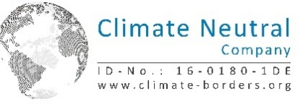

Please follow us on our social media channels: Instagram, Facebook, LinkedIn und YouTube.

