Why are oil changes also important for automatic transmissions? A new video from spare parts manufacturer MEYLE offers the answers.
Hamburg, 28 July Watch out: In a new YouTube video two experts from Hamburg-based manufacturer MEYLE explain what matters when changing the oil in automatic transmissions and which smart repair solutions from MEYLE simplify the job.
"Which oil for which transmission?", "How much oil?" and "At which change intervals?" – the practical poster for replacement intervals provides all the answers. Sparked your interest? You can download the poster here or order a print version to display in your workshop here.
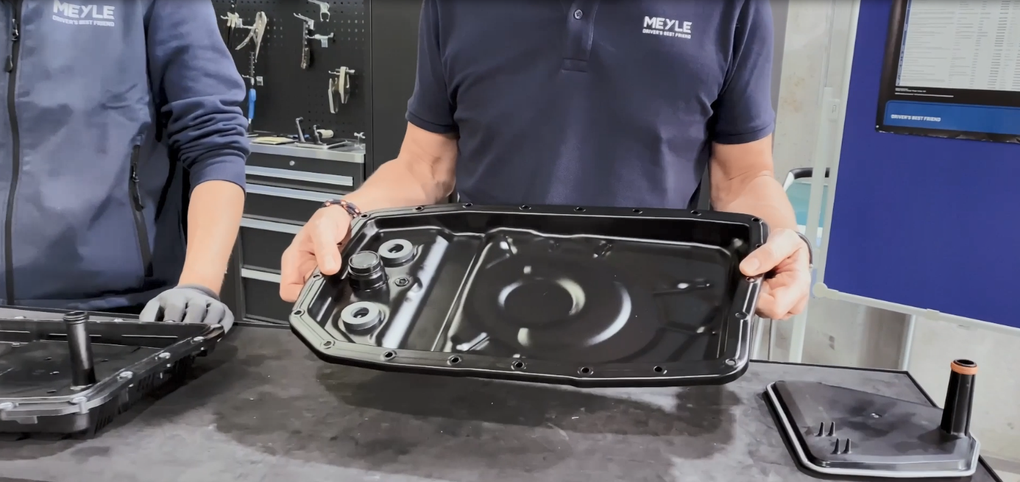Caption: The steel oil pan included in the MEYLE ORIGINAL Automatic Transmission Service Kit is particularly durable and sustainable thanks to the replaceable filter.
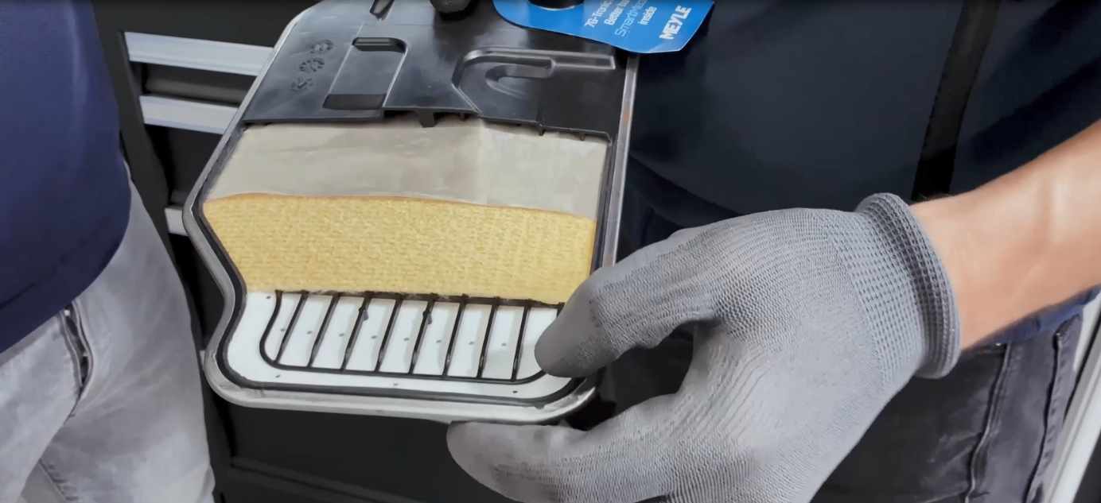Caption: The 7G-Tronic plus filter offers optimum filter performance with its three filter layers.

Contact:
1. Klenk & Hoursch AG, Frederic Barchfeld, tel.: +49 40 3020881 15, email: meyle@klenkhoursch.de
2. MEYLE AG, Benita Beissel, Tel.: +49 40 67506 7418, E-Mail: press@meyle.com

About the company
MEYLE AG is a company of Wulf Gaertner Autoparts AG.
MEYLE AG develops, produces and sells high-quality spare parts for passenger cars, vans and trucks for the independent aftermarket under the MEYLE brand. With its three product ranges – MEYLE ORIGINAL, MEYLE PD and MEYLE HD – MEYLE offers precise solutions and parts for every situation and every driver, from competent workshop employee and ambitious rally driver to classic car enthusiast and every driver around the world who needs to be able to rely on their own car. MEYLE offers its customers over 24,000 reliable and durable spare parts manufactured in their own plants and at the facilities of select production partners. The MEYLE product portfolio is correspondingly sophisticated.
The company network has some 1,000 employees worldwide, including nearly 500 in Hamburg, at the logistics centre and our company headquarters. We work with our partners, workshops and car mechanics in 120 countries to ensure that drivers can rely on our superior parts and solutions – that’s how MEYLE helps workshops to become the DRIVER’S BEST FRIEND.

MEYLE and Sustainability
MEYLE's headquarters is certified CO2-neutral by the non-profit organization Climate without Borders. To offset the emissions, we have donated to two Gold Standard certified climate protection projects in Africa: Efficient cooking stoves in Uganda and electricity from hydropower in Tanzania.
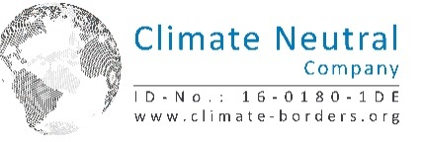

Please follow us on our social media channels: Instagram, Facebook, LinkedIn and YouTube.

We process your address data on the basis of your declaration of consent ("Consent to the processing of your data"). If you would like us to stop using your e-mail address to send you information of this kind in the future, you can object to processing for this purpose. We will of course take this into account in future actions. You can send your objection informally in writing to MEYLE AG, Merkurring 111, 22143 Hamburg or to the following e-mail address: press@meyle.com. However, as we plan our campaigns in advance, you may still receive information from us within a period of up to 21 days from the date of your objection. We ask for your understanding.

